Sean McLean
ALY 6980 Capstone
Professor Parker
Modules 4 & 6
Individual Project Proposal

Overview and Rationale
The focus of the project proposal is to explore the role of digital tools in franchise growth strategies, specifically examining how technology-driven franchise management impacts operational success. By integrating customer relationship management (CRM) and data analytics tools into strategy assessments, Big Sky Franchise Team can derive actionable insights to improve long-term business performance.
The proposed solution will incorporate multiple key business considerations:
- Data Governance: Proper data collection, storage, and security are crucial in managing franchise operations. This will ensure compliance with privacy regulations while maintaining accurate, reliable, and accessible data that is essential for making data-driven decisions.
- Business Leadership: The use of analytics in franchise management empowers leaders to make informed strategic decisions. Digital tools enhance customer engagement, implement new ways of operating and delivering services, and establish new revenue streams (Publicis Sapient, 2025).
- Ethical and Social Responsibility Challenges: Digital tools in franchise management must be implemented responsibly to ensure fair business practices, protect customer and franchisee data, and prevent biases in decision-making processes.
The proposal aims to demonstrate how digital solutions can help alleviate the complexities of these challenges and provide actionable recommendations for operational improvement.

Methodology
Data Points:
- Franchise performance metrics (revenue, customer retention rates, and growth rate).
- CRM data (customer interactions, purchase history, service inquiries).
- Marketing analytics (conversion rates, digital campaign performance, customer engagement).
- Industry benchmarks and comparative franchise data.
- Quantitative data that includes sales and revenue metrics, customer satisfaction scores, and operational efficiency metrics before and after the integration of digital tools.
- Employment data, such as the number of jobs created and employee performance metrics, will also provide insights into the economic impact of technology-driven franchise management.
- Qualitative data will be built through customer feedback, franchisee insights, and interviews with industry executives. The data will provide an understanding of the experiences and perceptions of those directly impacted by the digital tools.
- Based on the summary of Sabaran and Aziz (2023), an analysis can be proposed to evaluate the impact of mobile apps, data analytics platforms, and point-of-sale systems on customer experience and operational effectiveness. The analysis could involve a comparative study of performance metrics before and after adopting these technologies. It will also use correlation and regression analysis to explore the relationship between digital tools and key performance indicators and thematic analysis to identify recurring themes in qualitative data. A cost-benefit analysis could also assess the financial impact and return on investment of integrating digital tools into franchise management. This comprehensive approach aligns with the findings, emphasizing the importance of technological advancements in enhancing business operations and promoting corporate growth.
Data Sources:
- Internal datasets provided by Big Sky Franchise Team.
- Publicly available franchise industry reports and benchmarks.
- Online databases from outside providers.
- Competitor analysis via financial reports and case studies.

Data Usage
The collected data will be utilized in two primary ways:
- Dashboarding: A business intelligence (BI) dashboard will be developed to visualize key performance indicators (KPIs), making it easier for franchise leadership to monitor trends and performance in real-time.
- Predictive Modeling: Machine learning techniques, such as regression analysis and clustering, will be used to predict growth trends, optimize customer retention strategies, and identify operational inefficiencies.

Example Use Case
A predictive analytics model can be applied to franchise sales data to identify which factors contribute most to successful locations. By analyzing historical sales trends and operational data, the model can recommend strategies for new franchise openings, targeted marketing, and cost reduction.

Visualization of Methodology
A flowchart or dashboard prototype will be created to represent the data collection and analysis process, illustrating:
- Data sources
- Analytical tools used
- Dashboarding and predictive modeling applications
- Decision-making framework based on insights
- Visualizations to present showing analysis from Big Sky dataset where digital tools have been employed and where they can be most utilized in the future. An example of this below shows graphs of where lead sources from client accounts have been coming from in the past.
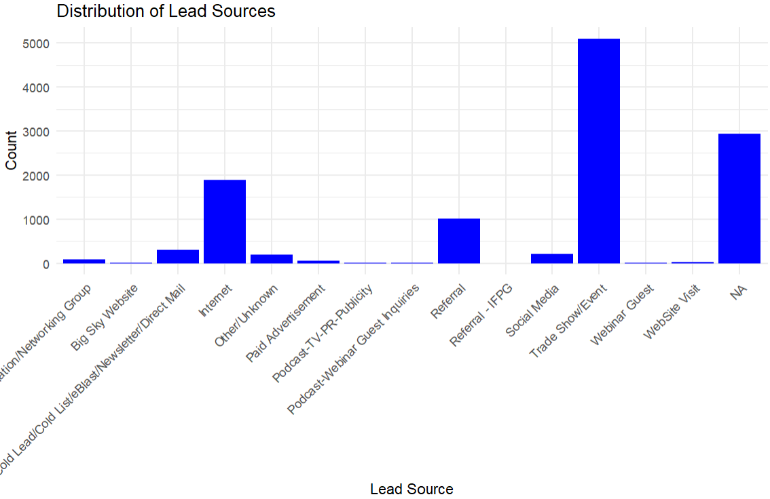
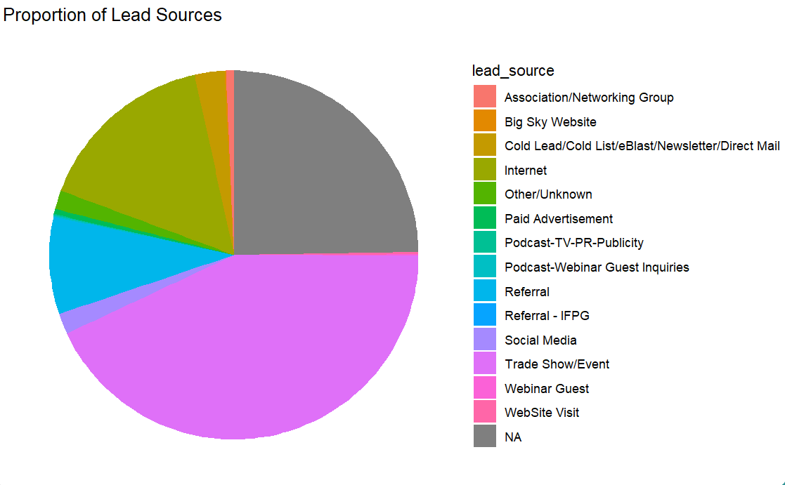
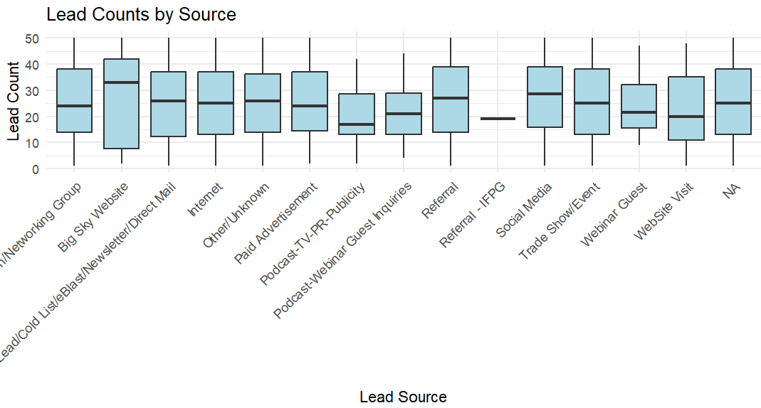
Survey Instrument: Defining the Survey Audience
The survey will focus on franchise owners, managers, and business executives within the Big Sky Franchise Team network. This group is essential as they actively use digital tools, and oversee CRM systems, and make strategic decisions that influence franchise growth. Collecting and analyzing their feedback will help evaluate the effectiveness of current digital solutions and identify operational challenges.
Designing The Survey: The survey will feature a mix of structured and open-ended questions to collect both quantitative and qualitative insights.
- Quantitative Questions: These will measure key performance indicators, such as CRM tool effectiveness, the influence of data analytics on decision-making, and overall satisfaction with digital tools.
- Qualitative Questions: Open-ended responses will explore the challenges franchisees face with digital tools, suggestions for improvement, and perceptions of digital transformation in franchise management.
Sample Questions:
- On a scale of 1-5, how effective are CRM tools in managing customer interactions?
- What are the biggest challenges you experience when using digital analytics for franchise operations?
- What digital tools have been used in the past for franchise operations and which ones have been the most effective?
- How has digital tool integration influenced your ability to make data-driven decisions?
- How can the incorporation of digital tools strengthen relationships between the franchisor and franchisee?
Survey Deployment Plan
- Distribution: The survey will be conducted online and distributed through email and internal communication channels.
- Timeline: It will remain open for a month, with a reminder sent at the end of the first week to encourage participation.
- Incentives: Participants may receive a summary of key insights to encourage engagement.
- Ethical Considerations: Responses will be anonymous to ensure honest feedback, and participants will be informed about how their data will be used to enhance franchise operations.
Insights from the survey will help refine digital tool integration strategies, ensuring that CRM and analytics solutions align with franchisee needs and drive operational success (Sparkleminds, 2024).
Literature Review
To strengthen the proposal, insights from industry articles, case studies, and scholarly research on franchising best practices and digital transformation will be incorporated. Sources from the annotated bibliography will support the need for CRM and analytics integration in franchise operations.
Annotated Bibliography
Rahatullah, M. K., & Raeside, R. (2008). Developing a model of franchise business relationships. Central Asia Business, 1(1), 21-33.
Rahatullah, M.K. and Raeside, R. (2008) examine the franchise relationships that are shaped by different forms of economic power, including coercive, legitimate, and reward-based influences. Coercive power enforces compliance, while legitimate power stems from contractual rights. As franchisers expand internationally, they can depend on economic-legal models to manage franchisee relationships, sometimes exerting control through master franchisees. Conflicts can arise due to behavioral, informational, and financial disagreements that could favor the franchiser despite legal frameworks aimed at balancing power dynamics. The resolution strategies vary, including negotiation, persuasion, and legal action, depending on the business sector and country regulations.
Trust and commitment are central to strong franchise relationships that lower opportunistic behavior as well as foster long-term collaboration. And effective communication, strategic alignment, and franchisee capacity-building efforts enhance stability and growth. Gaps do remain in understanding how trust develops, how contractual obligations influence cooperation, and how franchisees perceive franchiser control. To achieve synergy, franchise systems must prioritize collaboration and adaptability that will ensure that both parties benefit from a balanced and mutually supportive partnership.
Salar, M., & Salar, O. (2014). Determining pros and cons of franchising by using SWOT analysis. Procedia - Social and Behavioral Sciences, 122, 515–519. https://doi.org/10.1016/j.sbspro.2014.01.1385
The article looks at franchising through a SWOT analysis, defining it as a business model where franchisees operate under a franchisor’s brand and system. It highlights key advantages, including brand recognition, reduced failure risk, easy setup, an existing customer base, and financial support. Disadvantages such as high costs, dependency on franchisors, and strict operational rules are also discussed in the article. Salar concludes that the benefits outweigh the challenges which positions franchising as a viable business strategy.
While the article effectively assesses franchising's strengths, weaknesses, opportunities, and threats, it lacks empirical case studies or statistical comparisons of success rates. Despite this, it is highly relevant for research on franchising as an entrepreneurial strategy, offering valuable insights for business students, entrepreneurs, and policymakers interested in economic development through franchising. The analysis can also help with looking at how a SWOT analysis could be used toward the evaluation of past data with Big Sky and help define a solution to the business question.
Ghani, M. F. A., Hizam-Hanafiah, M., Mat Isa, R., & Abd Hamid, H. (2022, Sept. 3rd). A preliminary study: Exploring franchising growth factors of franchisor and franchisee. Journal of Open Innovation: Technology, Market, and Complexity, 8(3), 138. https://doi.org/10.3390/joitmc8030138
The article examines the growth factors influencing franchise success, focusing on product and service innovation, franchisor-franchisee relationships, and government support. Through analysis of interviews, the study highlights that innovation is crucial for maintaining competitiveness, requiring perpetual adaptation to technological advancements and market demands. Franchise systems benefit from incremental improvements rather than radical transformations, and marketing innovations enhance brand value and customer engagement. The study aligns with previous research indicating that firms with strong networking and learning capabilities are more likely to sustain growth through innovation.
The authors emphasize the importance of a strong franchisor-franchisee relationship that includes trust, communication, and financial support. Franchisors play a critical role in guiding franchisees by providing necessary resources, training, and financial flexibility, especially during crises like the COVID-19 pandemic. The research highlights that franchise success depends on mutual understanding, with financial reinvestment, tolerance, and cooperation essential for long-term growth. By fostering collaborative strategies and continuous learning, franchises can build resilience and sustain expansion in competitive markets. And leveraging past company data to enhance innovation, strengthen franchisor-franchisee relationships, and improve targeted marketing strategies, Big Sky can drive higher franchisee transactions and build stronger connections with prospective business clients.
Alon, I., Ni, L., & Wang, Y. (2011, Jan.). Examining the determinants of hotel chain expansion through international franchising. International Journal of Hospitality Management. (PDF) Examining the determinants of hotel chain expansion through international franchising
This study explores the internationalization of hotel chains through franchising, using an agency-based organizational model. Analyzing data from 17 U.S.-based hotel chains between 2001 and 2008, the research identifies a positive correlation between the percentage of franchises and the decision to expand internationally. The study highlights the challenges of the capital-intensive nature of hotel ownership and the benefits of franchising as a non-equity expansion strategy. It also emphasizes the significance of franchise experience, size, and monitoring skills in successfully internationalizing. Larger hotel companies benefit from economies of scale, brand recognition, and managerial expertise, making it easier to attract international franchisees and manage operations. The findings demonstrate the importance of organizational factors and market conditions in the international expansion process.
In relation to my proposal which focuses on the role of digital tools in franchise growth strategies, the study's insights on franchise experience, monitoring skills, and size can be enhanced through technology-driven management. By integrating CRM and data analytics tools, Big Sky Franchise Team can gain actionable insights to optimize franchise operations and support international expansion efforts. Digital tools can also streamline processes, improve monitoring capabilities, and provide valuable data to make informed decisions. This will align with the study's emphasis on the significance of organizational factors and market conditions. This approach can lead to improved long-term business performance and operational success in the international market.

Implementation Plan
- Phase 1: Data Collection & Analysis
  - Gather relevant data from company-provided datasets and external sources.
  - Perform comparative analysis with other franchising models.
- Phase 2: Identifying Improvement Areas
  - Conduct SWOT analysis to identify strengths, weaknesses, opportunities, and threats.
  - Develop a strategic framework for digital tool integration.
- Phase 3: Proposal Development & Recommendations
  - Present findings with both short-term and long-term implementation strategies.
  - Assess potential challenges and propose mitigation strategies.
  - Provide a roadmap with realistic timelines for adopting proposed changes.

Conclusion
This proposal aims to highlight how integrating digital tools can drive franchise growth, enhance decision-making, and ensure long-term operational success. By leveraging CRM and analytics, Big Sky Franchise Team can gain a competitive edge while improving overall franchisee and customer experience. This can also result in improved digital business leadership practices that will enhance digital inclusion, transform business operations, and increase the responsibilities that protect the planet (Claremont Lincoln University, 2025). Overall, the proposal will effectively complement the group project that seeks to improve future outcomes for Big Sky Franchising Team.

References
Publicis Sapient. (2025). Digital Business Transformation: The Guide to Future-Proofing Your Business. Publicis Sapient. https://www.publicissapient.com/digital-business-transformation?utm_source=google&utm_medium=paid-search&utm_campaign=BRAND_ALW_DBT_07.2024_Paid.Search_Google_Text_US_GEN_OF.NO&utm_content=BRAND_ALW_DBT_Digital.Transformation_2&utm_category=Brand&OfferingFamily=OF.NO&utm_term=digital%20transformation&gad_source=1&gclid=CjwKCAiA74G9BhAEEiwA8kNfpfKGUk2sCz8k2lyg4LKVUn05WAoyvhgPVAOX3zJNzYOSpsPQD3sgkRoCM18QAvD_BwE
Claremont Lincoln University. (2025). Digitial Leadership: Benefits And Strategies For Organizational Leaders. Claremont Lincoln University. https://www.claremontlincoln.edu/news-blog/digital-leadership-strategies/
Sparkleminds. (2024, May 9th). Steps To Create the Perfect Franchise Questionnaire before appointing a franchisee in India. Sparkleminds. https://www.sparkleminds.com/2024/05/09/steps-to-create-an-effective-franchise-questionnaire/
Sabaran, N. N. H., & Abd Aziz, N. A (2023, Dec. 11th). Technology Adoption In Franchising Business: Understanding Factors And Challenges. Journal of Technology and Operations Management, 18(2), 49-59. https://doi.org/10.32890/jtom2023.18.2.4

